|  |  |
| --- | --- |
|  | **THE MIZUHO SECURITIES**  **ASIA LIMITED** |

**Data Analytics Platform**

**Deployment guide**

|  |  |
| --- | --- |
|  |  |
| Prepared by | Eastech Systems Limited |
| Document Version | v0.1 |
| Date | Dec 2, 2024 |

Revision History

|  |  |  |  |
| --- | --- | --- | --- |
| **Date** | **Author** | **Version** | **Description** |
| 2nd Dec, 2024 | Jasper Cheung | v0.1 | Document created. |
|  |  |  |  |
|  |  |  |  |
|  |  |  |  |

Reviewers

|  |  |  |  |
| --- | --- | --- | --- |
| **Name** | **Position** | **Version** | **Date** |
|  |  |  |  |
|  |  |  |  |
|  |  |  |  |
|  |  |  |  |

Distributions

|  |  |  |
| --- | --- | --- |
| **Department** | **Name** | **Position** |
| Information Technology Department | Gordon Lo | Vice President |
|  |  |  |
|  |  |  |
|  |  |  |

**Table of Contents**

1 Introduction 5

1.1 Purpose of Document 5

1.2 Architecture of the Data Analytics Platform 5

2 Data Factory 6

2.1 Export ARM Template 6

2.2 Import ARM Template 8

3 Synapse Analytics 12

3.1 Stored Procedure Deployment 12

4 SQL Server Reporting Services (SSRS) 13

4.1 Deploy SSRS Report Template 13

4.2 Export SSRS Report Subscription 17

4.3 Import SSRS Report Subscription 18

# Introduction

## Purpose of Document

This document serves as a comprehensive reference guide to facilitate the deployment of configuration settings and artifacts across Azure Data Factory, Synapse Analytics, and SQL Server Reporting Services (SSRS). The document outlines the deployment procedures to assist in maintaining a seamless transition between the development and production environment. By following this guide, the IT team can ensure adherence to minimize deployment risks and maintain system stability across platforms.

## Architecture of the Data Analytics Platform

The diagram below provides an overview of the architecture of the Data Analytics Platform.

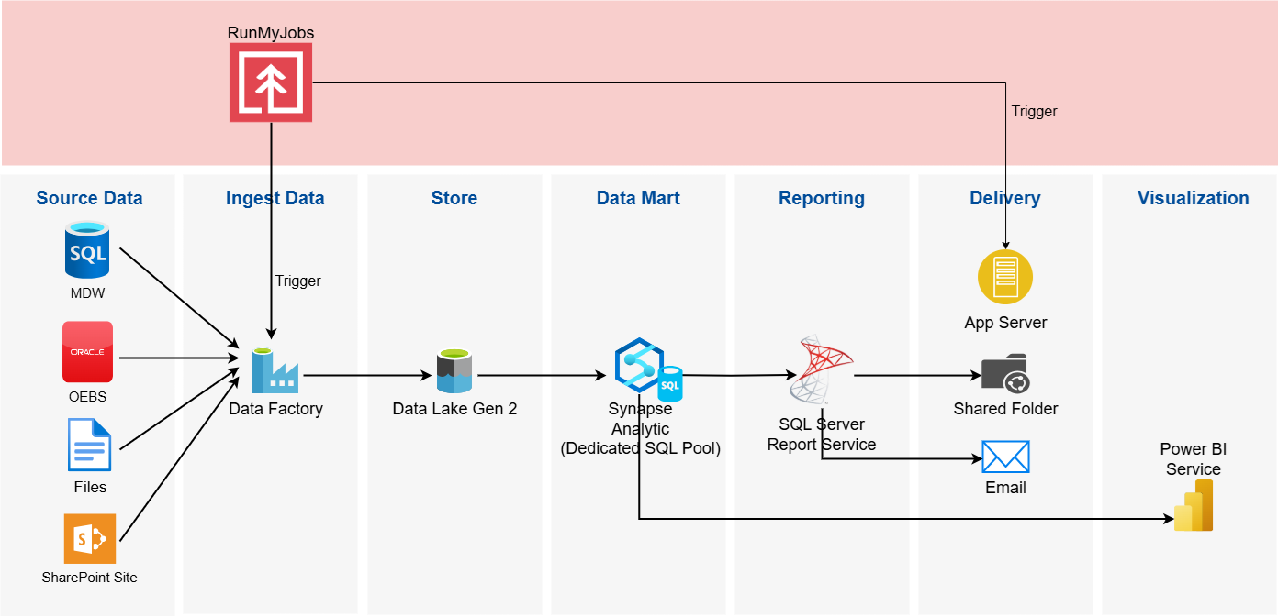

The architecture consists of the following Azure components:

* Data Factory: Orchestrates and automates data integration and ETL processes.
* Data Lake Gen 2: Scalable, secure, and cost-effective data lake storage solution.
* Synapse Analytics: Unified analytics platform for big data and real-time analytics.
* SQL Server Reporting Services (SSRS): Reporting platform for creating, deploying, and managing reports.
* Power BI Services: Cloud-based business analytics service for data visualization.

In brief, the Data Factory pipeline is designed to extract data from source databases and input files located in a shared folder. It transfers the necessary data into the Azure Data Analytics Platform, where it is stored in the data lake. This data is then mounted to the SQL Pool in Synapse Analytics as an external table, creating a result data set for reporting. SQL Server Reporting Services (SSRS) generates reports using these result datasets. The generated reports can either be saved in the shared folder or sent via email, depending on the subscription settings in SSRS. Additionally, Power BI services will be used to visualize the data in the SQL Pool through a dashboard.

# Data Factory

Azure Data Factory (ADF) is a cloud-based data integration service that allows organizations to orchestrate and automate data movement and transformation workflows on a scale. ADF supports a rich set of activities, including data copy, data transformation, and pipeline orchestration, making it a key component for building end-to-end data workflows in modern data solutions. To ensure consistent deployment and infrastructure-as-code (IaC) practices, ADF supports Azure Resource Manager (ARM) templates. ARM templates are JSON-based configuration files that define ADF resources, including pipelines, datasets, linked services, and triggers.

## Export ARM Template

1. Access the Azure Data Factory studio of the development environment (hksynd01df) in the Azure Portal.

1. Select **Manage** on the left navigation pane.

1. Select the **ARM template** from the **Manage** page. Then, click **Export** to export the ARM template of the Data Factory.

1. A file arm_template.zip will be downloaded and two files will be included in the zip file, **ARMTemplateForFactory.json** and **ARMTemplateParameterForFactory.json**.

## Import ARM Template

1. Access the Azure Data Factory studio of the development environment (hksynp01df) in the Azure Portal.

1. Select **Manage** on the left navigation pane.

C

1. To back up the existing Data Factory, select the **ARM template** from the **Manage** page. Then, click **Export** to export the ARM template of the Data Factory.

1. Click **Import on Azure Portal** to import the ARM template exported from the development environment (hksynd01).

1. Click **Build your own template in the editor** and a template editor will be opened in the browser tab.

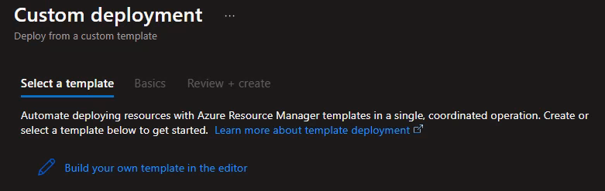

1. Copy the content of **ARMTemplateForFactory.json** from the development environment (hksynd01).

1. Click the **Save** button on the bottom left-hand side.
2. Click **Edit parameters** and a parameters editor will be opened in the browser tab.

1. Press **Ctrl + H** and use the find and replace function to perform a global replacement of the following keywords in the parameter’s configuration.

* *hksynd01* 🡪 *hksynp01*
* *SYN_nonprod* 🡪 *SYN_prod*

1. Click the **Save** button on the bottom left-hand side.
2. In the **Resource group** drop-down menu, select SYN_prod as the resource group to apply the configuration.

1. Click the **Review + create** button at the bottom left corner to proceed.

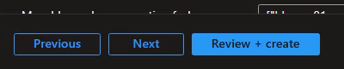

1. Client the **Create** button to apply the configuration.

# Synapse Analytics

Azure Synapse Analytics is an integrated cloud-based analytics service that combines big data and data warehousing capabilities into a unified platform. It enables organizations to ingest, store, process, and analyze large volumes of data using SQL pools (dedicated and serverless), and Spark pools.

## Stored Procedure Deployment

1. TBC

# SQL Server Reporting Services (SSRS)

## Deploy SSRS Report Template

1. Open the [SSRS portal](https://hkwninsqld041v/ReportServer) in the development environment with a web browser.

1. Navigate to the paginated report template in the DEV/UAT folder that is planned to be deployed.
2. On the target paginated report template, click the **ellipse** button and select **Download** from the pop-up menu.

1. The report template will be downloaded to the desktop download folder.
2. Copy the report template to the SSRS server in the production environment (hkwninsqlp034v) and deploy it on the server with the service account. By performing the upload at the SSRS server (hkwninsqlp034v), the owner of the report template will be the service account.
3. Using the remote desktop connection to connect the SSRS server in the production environment (hkwninsqlp034v) with the service account (app_hk_pbiprd_adm).

1. Open the SSRS portal (<https://hkwninsqlp034/Reports/browse>) on the SSRS server (hkwninsqlp034v) with a web browser.

1. Navigate to the target folder for the report template planned to deploy.
2. Click **⭱Upload** to upload the paginated report template downloaded previously.

1. On the paginated report template, click on the **ellipse** button and select **Manage** from the pop-up menu.

1. Since the report template is from the development environment, the data source configuration must be updated to the data source in the production environment. From the Manage pane, select **Data sources**. Then, click the ellipse button to open the data source configuration dialog box.

1. Select the appropriate shared data source for the report template.

1. Click the Save button to save the configuration.

## Export SSRS Report Subscription

1. Using the remote desktop connection to connect the SSRS server in the development environment (hkwninsqld041v) with the service account (app_hk_pbidev_adm).

1. Open a Windows PowerShell command prompt.

1. Export the report template subscription configuration in XML with the following command:

Get-RsSubscription -ReportServerUri '<SSRS_server_URL>' -RsItem '<report_template_name>' | Export-RsSubscriptionXml '<export_location>'

For example:

* SSRS server URL: <https://hkwninsqld041v/ReportServer>
* Report template name: FO_OrderTicketEMSXEquityReport
* Export location: C:\Temp\Data Driven Subscription

The command would be:

Get-RsSubscription -ReportServerUri 'https://hkwninsqld041v/ReportServer' -RsItem '/FO_OrderTicketEMSXEquityReport' | Export-RsSubscriptionXml 'C:\Temp\Data Driven Subscription\FO_OrderTicketEMSXEquityReport.xml'

1. An XML file of the report subscription configuration will be created in the target folder.
2. Copy the XML file to the SSRS report server in the production environment (hkwninsqlp034v) and follow the steps in the next section to deploy the subscription configuration to the report template.

## Import SSRS Report Subscription

1. Using the remote desktop connection to connect the SSRS server in the production environment (hkwninsqlp034v) with the service account (app_hk_pbiprd_adm).

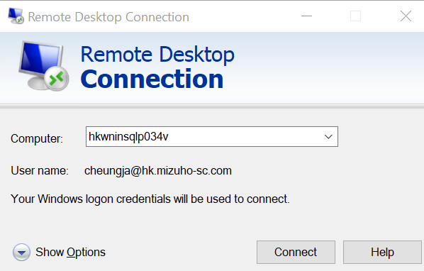

1. Open a Windows PowerShell command prompt.

1. Edit the subscription configuration XML file exported in the previous section with the PowerShell script **UpdateSubConfigXML.ps1**. The script is located at D:\Release\scripts.

D:\Release\scripts\UpdateSubConfigXML.ps1 -InputFile <subscription_config_xml> -SharedDataSource <data_source_name>

1. For example, with the following input arguments the command will be:

* Shared data source name: /hksynp01sql
* Input file path: D:\Release\FO_CounterPartyAmendment.xml

D:\Release\scripts\UpdateSubConfigXML.ps1 -InputFile "D:\Release\FO_CounterPartyAmendment.xml" -SharedDataSource "/hksynp01sql"

The script will change the owner of the subscription with the name of the service account and the connection to the shared data source in the production environment.

For the value of the shared data source, it refers to the connection that is used by the query in the subscription configuration. In normal situations, it should be “**hksynp01sql**”.

1. Import the report template subscription configuration in XML with the following command:

Import-RsSubscription '<subscription_config_xml>' -ReportServerUri '<SSRS_server_URL>' | Copy-RsSubscription -ReportServerUri '<SSRS_server_URL>' -RsItem '/<report_folder>/<report_template_name>'

For example, with the following input arguments the command will be:

* Subscription configuration XML path: D:\Release\FO_CounterPartyAmendent.xml
* SSRS server URL: https://hkwninsqlp034v/ReportServer
* Report folder: FO
* Report template name: FO_CounterPartyAmendent

Import-RsSubscription 'D:\Release\FO_CounterPartyAmendent.xml' -ReportServerUri 'https://hkwninsqlp034v/ReportServer' | Copy-RsSubscription -ReportServerUri 'https://hkwninsqlp034v/ReportServer' -RsItem '/FO/FO_CounterPartyAmendent'

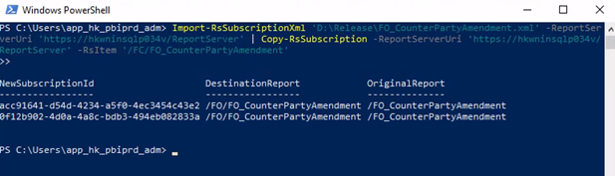

1. If an error occurs with the ReportServiceTool module when executing the Import-RsSubscription command, follow steps 7 to 9 to resolve the issue.

1. Execute the following command in the Windows PowerShell for using the ReportingServicesTools module.

Set-ExecutionPolicy -Scope Process -ExecutionPolicy Bypass

1. Enter “Y” to proceed. As the ReportServicesTools is from the PowerShell gallery and the copyright is from Microsoft Corporation, it is safe to proceed.

1. Reload the ReportingServiceTools module with the following command.

Install-Module -Name ReportingServicesTools

1. To validate that the subscription configuration has been imported successfully, open the SSRS portal (<https://hkwninsqlp034v/Reports/browse>) in the production environment with a web browser.
2. Navigate to the folder of the report template for the deployment.
3. Click the **ellipse** button and select **Manage** from the pop-up menu.

1. Click **Subscriptions** from the Manage pane.

1. Check the subscription entries that have just been imported. Then, click **Edit** to validate the configuration of the subscription.

